EVENTS AND WORKSHOPS@
Autism Hub 2020
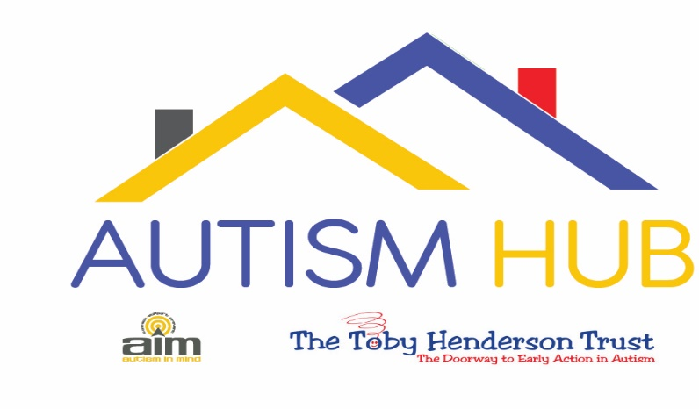
Unfortunately we cannot accommodate babies or children in any workshops
ALL PLACES MUST BE BOOKED
Event | Date | Location | Price
Daughter’s with ASD  Support Group  With Sam Carney & Sheila Davies | Wednesday 29th January 2020  10am – 11.30am | Autism Hub | FREE for parents in South Tyneside
Autism & Mental Health Difficulties in Children & Young People Workshop.  With Carolyn Morgan | Tuesday 4th February 2020.  12.30pm – 2.30pm | Autism Hub | FREE for parents in South Tyneside
“Newly diagnosed/Going through diagnosis” Support Group  With Sam Carney & Sheila Davies | Wednesday 26th February 2020  10am – 11.30am | Autism Hub | FREE for parents in South Tyneside
A Grandparents Guide to Autism  Session 1 of 4  With Sam Carney & Sheila Davies | Wednesday 26th February 2020  12.30pm – 2pm | Autism Hub | FREE for Grandparents in South Tyneside
Autism Friendly Swimming session  Everyone welcome | Saturday 29th February 2020  6pm – 6.45pm | Waves Whitley Bay | £5 per swimmer
Pathological Demand Avoidance (PDA) Workshop  With Anna Knight | Wednesday 4th March 2020  10am- 12noon | Autism Hub | FREE for parents in South Tyneside
Q&A session with Anna Knight. Specialist Speech, Language & Behavioural Therapist. | Wednesday 4th March 2020  1pm – 2.30pm | Autism Hub | FREE for parents in South Tyneside
A Grandparents Guide to Autism  Session 2 of 4  With Sam Carney & Sheila Davies | Wednesday 10th March 2020  12.30pm – 2pm | Autism Hub | FREE for Grandparents in South Tyneside
Sensory Issues Workshop  With Rachel McManus | Tuesday 17th March 2020  1pm – 3pm | Autism Hub | FREE for parents in South Tyneside
Toileting Workshop  With Julie Curtis | Wednesday 18th March  9.30am – 11.30am | Autism Hub | FREE for parents in South Tyneside
A Grandparents Guide to Autism  Session 3 of 4  With Sam Carney & Sheila Davies | Wednesday 18th March 2020  12.30pm – 2pm | Autism Hub | FREE for Grandparents in South Tyneside
Son’s with ASD  Support Group  With Sam Carney & Sheila Davies | Wednesday 25th March 2020  10am -11.30am | Autism Hub | FREE for parents in South Tyneside
A Grandparents Guide to Autism  Session 4 of 4  With Sam Carney & Sheila Davies | Wednesday 25th March 2020  12.30pm – 2pm | Autism Hub | FREE for Grandparents in South Tyneside
Introduction to Makaton  With Cheryl Wade | Monday 30th March 2020  10.30am – 12.30pm | Autism Hub | FREE for parents in South Tyneside
Managing Meltdowns Workshop  With Julie Curtis | Wednesday 1st April 2020  9.30am – 11.30am | Autism Hub | FREE for parents in South Tyneside
Sibling Superstars Workshop | Wednesday 8th April 2020  10.30am – 2.30pm | Autism Hub | Free for Siblings in South Tyneside aged 7 – 15.
Parenting & communicating with teenagers with ASD Workshop  With Carolyn Morgan | Tuesday 28th April 2020.  12.30pm – 2.30pm | Autism Hub | FREE for parents in South Tyneside
Sleep Workshop  With Julie Curtis | Wednesday 6th May 2020  9.30am – 11.30am | Autism Hub | FREE for parents in South Tyneside
Q&A session with Julie Curtis. Specialist LD Nurse Consultant | Wednesday 6th May 2020  12.30pm - 2pm | Autism Hub | FREE for parents in South Tyneside

