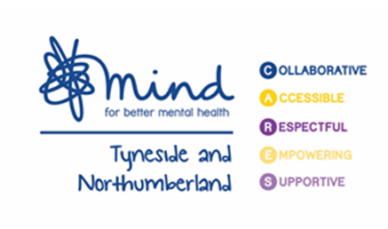
Tyneside and Northumberland Mind have launched a new support line from 08.00am until 8.00pm every weekday until 31st March 2021.

This will provide a friendly voice and listening ear on the end of a phone.
Please call (0191) 4774545

Charity Number 1140856 Company Number 7552434

